# Projecto 3 – Instruções

## Adicionar Spring Web + Web-MVC ao projecto

1. Adicionar dependencias Maven

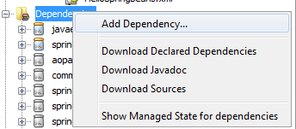 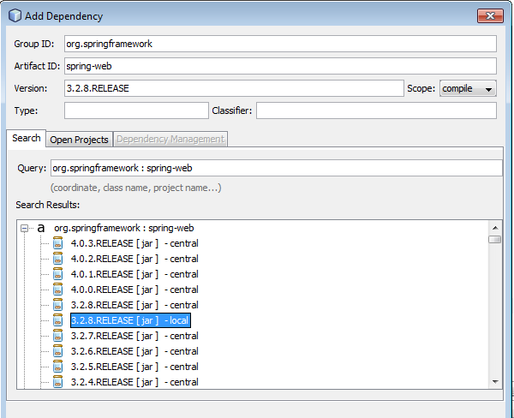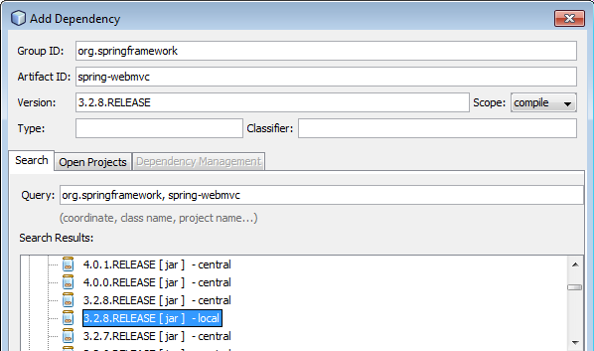

Opcionalmente, adicionar diretamente ao pom.xml:

*<!-- Spring framework -->*

**<dependency>**

**<groupId>**org.springframework**</groupId>**

**<artifactId>**spring-core**</artifactId>**

**<version>**3.2.8.RELEASE**</version>**

**</dependency>**

*<!-- Spring web mvc -->*

**<dependency>**

**<groupId>**org.springframework**</groupId>**

**<artifactId>**spring-web**</artifactId>**

**<version>**3.2.8.RELEASE**</version>**

**</dependency>**

**<dependency>**

**<groupId>**org.springframework**</groupId>**

**<artifactId>**spring-webmvc**</artifactId>**

**<version>**3.2.8.RELEASE**</version>**

**</dependency>**

1. Clean & Build
2. Resultado  
   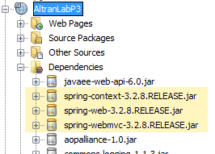

## Criar um controller

